Section 1: Solve the following questions using substitution.
- 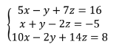

- 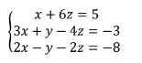

- 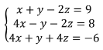

Section 2: Solve the following using Elimination
- 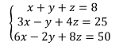

- 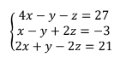

- 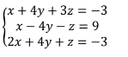

Section 3: Formulate and solve the following problems
- 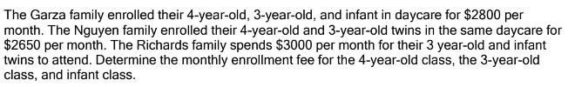

- 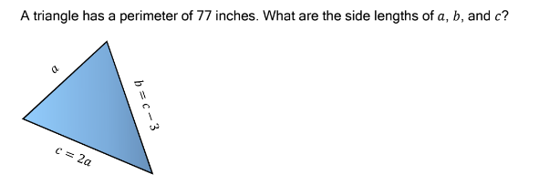

- 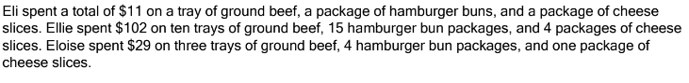

Section 4: Determine possible solutions for the situation.
